**EXERCISE 2.3**

**RULES**

**MANTISSA**

Number After Decimal point is called Mantissa.

**CHARACTERISTICS**

Number before Decimal point is called Characteristics.

RULE: IF Before Decimal present any integer than we used technique (i), (ii), (iii) and (iv) questions

RULE: If Before Decimal present only zero then we used below equation

-(X+1)

X = Zeros present after Decimal Like 0.000998 , So X = 3

Characteristics = -(X+1) = -4

Mantissa = log(998) = 2.9991 = 0.9991

Log a* b = loga + log b

Log (a/b) = loga – logb

Log ab = b Log a

**1. Find the characteristics and mantissa of the following Logarithm**

**(i) 8**

**SOLUTION**

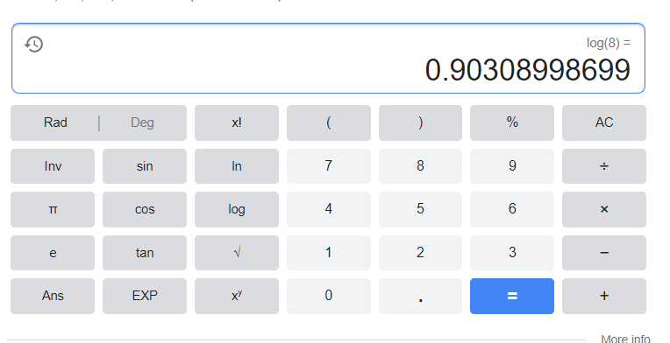

**Characteristics = 0**

**Mantissa = 0.9031 -----------------Answer**

**(ii) 5054**

**SOLUTION**

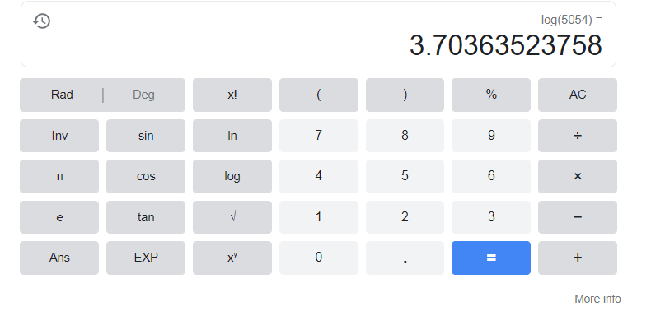

**Characteristics = 3**

**Mantissa = 0.7036------------------Answer**

**(iii) 9.992**

**SOLUTION**

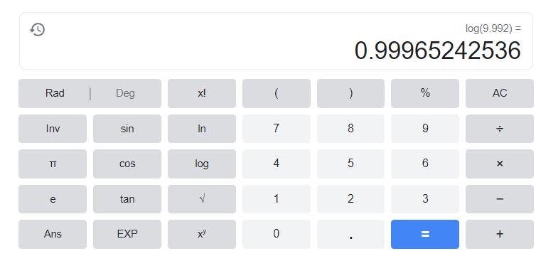

**Characteristics = 0**

**Mantissa = 0.9997------------------Answer**

**(iv) 765.3**

**SOLUTION**

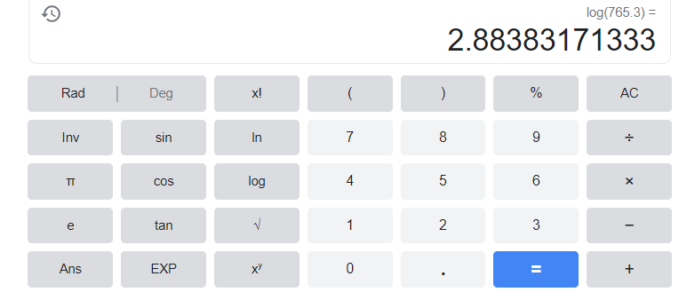

**Characteristics = 2**

**Mantissa = 0.8839------------------Answer**

**(v) 0.00329**

**SOLUTION**

-(X+1)

X = Zeros present after Decimal = 2

**Characteristics = -(2+1) = -3**

**Mantissa = log(329) = 2.5172 = 0.5172 --------Answer**

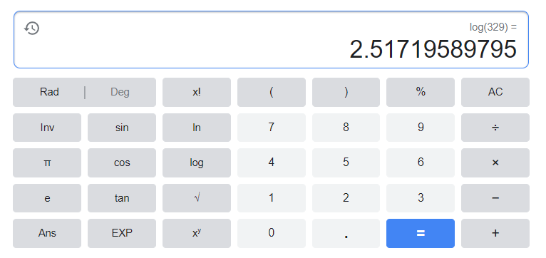

**(vi) 0.0000300**

**SOLUTION**

-(X+1)

X = Zeros present after Decimal = 4

**Characteristics = -(4+1) = -5**

**Mantissa = log(300) = 2.4771 = 0.4771 --------Answer**

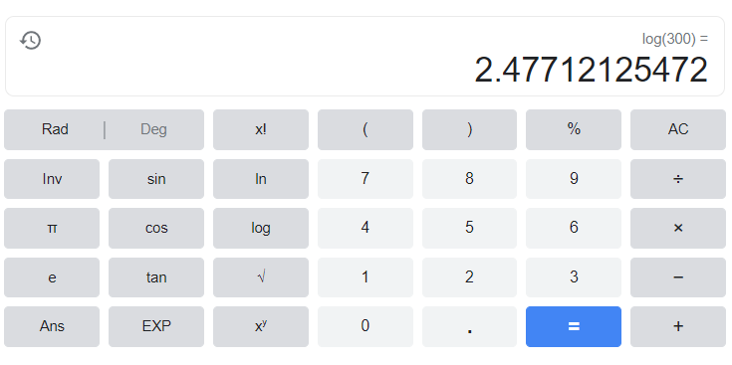

**2. Find the logarithms of the following numbers.**

**IS LOG TABLE MEN HUM SIRAF 4 DIGIT TAK VALUE LEA SAKTEA HEN.**

**AGAR NUMBER 4 DIGIT SEA KUM KA HEA TOO HUM APNEA TARAF SEA ZEROS ADD KERKEA 4 DIGIT KA BANA DEEN GEA**

**(i) 9**

SOLUTION

9 = 9.0

Numbers Before Decimal = D = 1

Number = N = D-1 = 1-1 = 0

Let x = 9

Taking log on both sides

Log x = log(9), here is rule to find the log, we required 4 digit

Log x = log(9.000)

Log x = N. 90 0 0

Log x = 0. (9542+0) = 0.9542------ ----- Answer

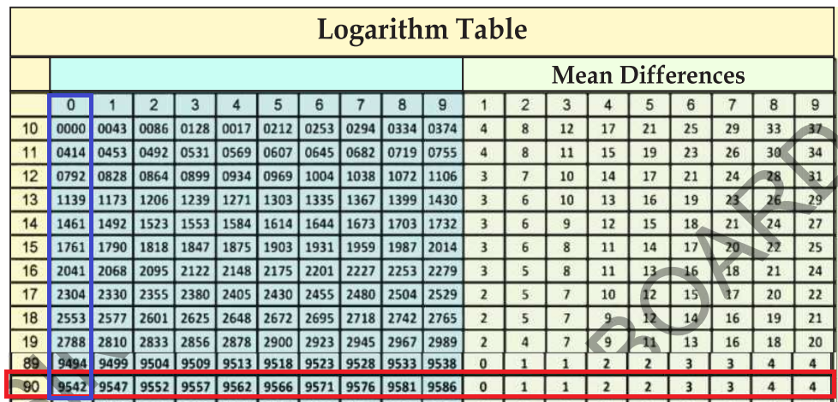

**(ii) 55.56**

SOLUTION

Numbers Before Decimal = D = 2

Number = N = D-1 = 2-1 = 1

Let x = 55.56

Taking log on both sides

Log x = log(55.56)

Log x = N. 55 5 6

Log x = 1. 55 5 6 = 1. (7443 + 5) = 1.7448 ----- Answer

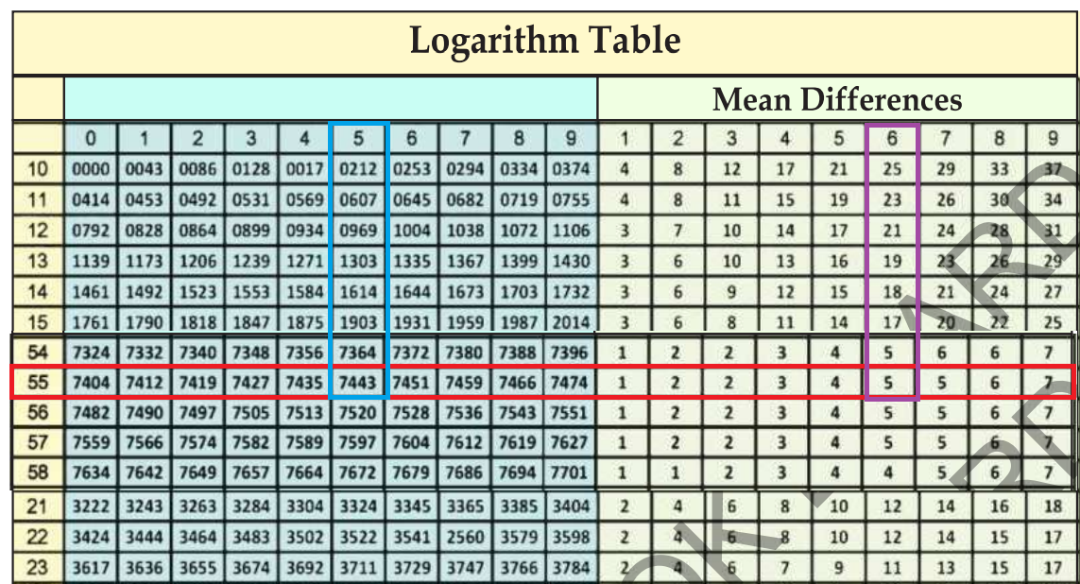

**(iii) 29.592**

SOLUTION

Numbers Before Decimal = D = 2

Number = N = D-1 = 2-1 = 1

Let x = 29.592

Taking log on both sides

Log x = log(29.592) = log(29.59)

Log x = N. 29 5 9

Log x = 1. 29 5 9 = 1. (4698 +13) = 1.4711 ----- Answer

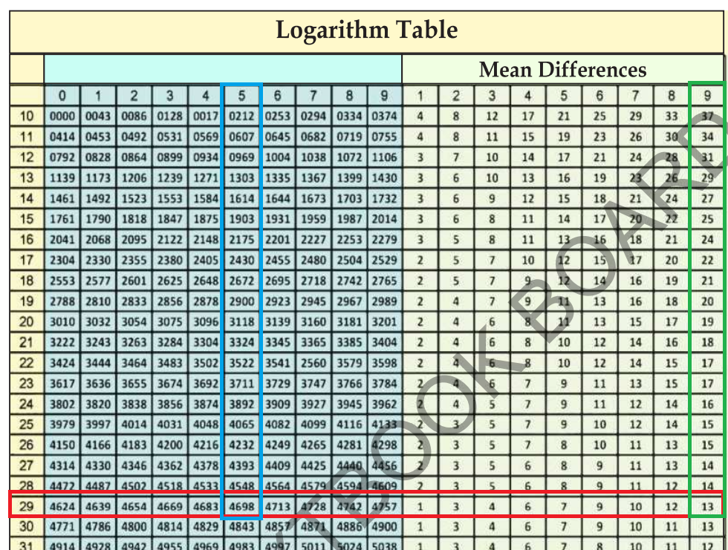

**(iv) 405.3**

SOLUTION

Numbers Before Decimal = D = 3

Number = N = D-1 = 3-1 = 2

Let x = 405.3

Taking log on both sides

Log x = log(405.3)

Log x = N. 40 5 3

Log x = 2. 40 5 3 = 2. (6075 +3) = 2.6078 ----- Answer

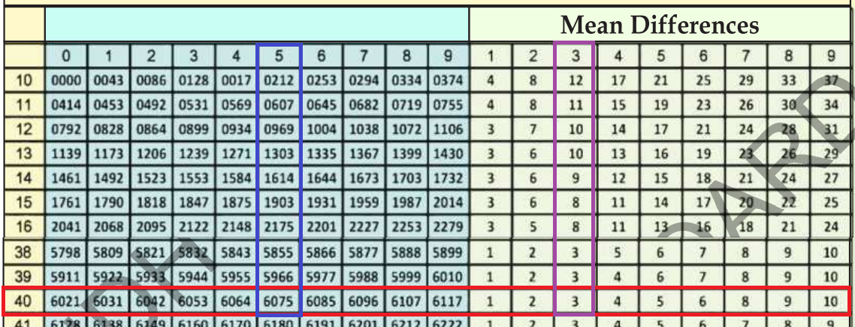

**(v) 0.00469**

SOLUTION

0.00469 = 4.69*10-3

Numbers Before Decimal = D = 1

Number = N = 1-1 = 0 = 0

x = 4.69*10-3

Taking log on both sides

Log x = log(4.69*10-3) = log(4.69) + log (10-3)=

Log x = log(4.690) – 3 log(10)

Log x = log(4.690) – 3*1

Log x = [log(4.690)] – 3

Log x = [46 9 0] – 3 = 6712 – 3

Log x = N.6712 – 3

Log x = 0.6712 – 3

Log x = -2.3288 ---------Answer

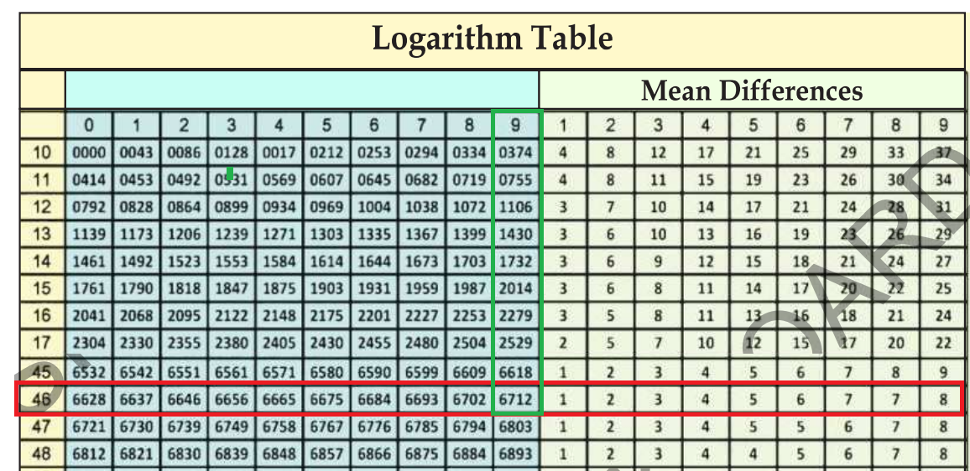

**(v) 0.000076**

SOLUTION

0.000076 = 7.6*10-5

Numbers Before Decimal = D = 1

Number = N = 1-1 = 0 = 0

x = 7.6*10-5

Taking log on both sides

Log x = log(7.6*10-5) = log(7.6) + log (10-5)

Log x = log(7.6) – 5 log(10)

Log x = log(7.6) – 5*1

Log x = [log(7.6)] – 5

Log x = [log(7.600)] – 5

Log x = [76 0 0] – 5 = 8808 – 5

Log x = N.8808 – 5

Log x = 0.8808 – 5

Log x = -41192 ---------Answer

**3. If log 31.09 = 1.4926, find the value of the following without using log table.**

**(i) log 3.109**

**SOLUTION**

Log 31.09 = 1.4926

Log 3.109 = 1.4926 – 1 (because value down from higher to lower and shift one place, so subtract -1)

Log 3.109 = 0.4926 ---------Answer

**(ii) log 310.9**

**SOLUTION**

Log 31.09 = 1.4926

Log 310.9 = 1.4926 + 1

Log 310.9 = 2.4926 ---------Answer

**(iii) log 0.003109**

**SOLUTION**

Log 31.09 = 1.4926

Log 0.003109 = 1.4926 - 4

Log 0.003109 = -2.5074 ---------Answer

**(iv) log 3109.0**

**SOLUTION**

Log 31.09 = 1.4926

Log 3109.0 = 1.4926 +2

Log 3109.0 = 3.4926 ---------Answer

**(v) log 310.942**

**SOLUTION**

Log 31.09 = 1.4926

Log 310.942 = 1.4926 +1

Log 310.942 = 2.4926 ---------Answer

**(vi) log 310926**

**SOLUTION**

Log 31.09 = 1.4926

Log 310926. = 1.4926 +4

Log 310926 = 5.4926 ---------Answer